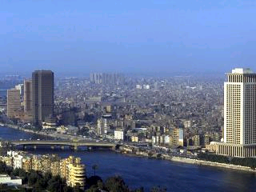

**Table of contents**

|  |  |
| --- | --- |
|  | **Page number** |
| 1. **Delta module 2 aims** | **2** |
| 1. **General description** | **3** |
| 1. **Assessment and grades** | **3** |
| 1. **Plagiarism** | **5** |
| 1. **Resubmission** | **5** |
| 1. **Complaints** | **5** |
| 1. **Equality policy** | **6** |
| 1. **Information on British Council Egypt and Cairo** | **7** |
| 1. **Reading list** | **Available on the website** |

**Introduction to Delta Module Two**

Delta Module Two aims to develop candidates’ ability in the following areas:

* working with language learners in a variety of learning contexts
* preparation for teaching learners of English
* evaluation, selection and use of resources and materials for teaching purposes managing and supporting learning
* evaluation of lesson preparation and teaching
* observation and evaluation of other teachers’ lessons
* professionalism and professional development

To achieve these aims candidates need to show that they are able to:

* research selected language/skills areas and focus on problems and solutions for learners
* apply their knowledge and understanding of factors affecting learning and teaching to their practice
* plan, teach and evaluate lessons which meet the needs of specific groups of learners and individuals within the groups
* use a range of resources and materials, and teaching and learning strategies which are appropriate to learner needs and context
* constructively evaluate their own teaching and engage in Continuing Professional Development (CPD).

**The full syllabus can be downloaded at**

[www.CambridgeESOL.org/exams/teaching-awards/deltamodular.html](http://www.CambridgeESOL.org/exams/teaching-awards/deltamodular.html)

Module Two is assessed via a portfolio of coursework, including background essays, observed lessons, and a professional development assignment. One assignment which includes a background essay, an observed lesson and a lesson evaluation is externally assessed.

**General description**

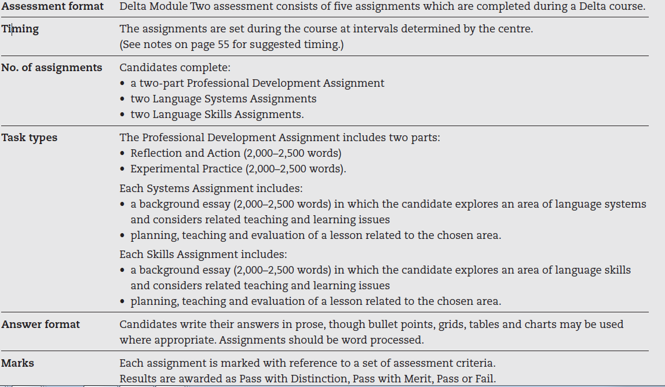

This was copied from the Cambridge ESOL DELTA handbook <http://www.cambridgeenglish.org/de/images/22078-delta-handbook.pdf>

**Assessment**:

1. **Internal assessment**

Three of the Language Systems/Skills Assignments are internally assessed by Delta course tutors at the centre. For each assignment, centres give two grades, one for the background essay and one for the lesson.

The Professional Development Assignment (PDA) is also internally assessed.

*Coursework record*

During the course, tutors log details of all the internal coursework in the Coursework Record (Delta 5c), which is completed for each candidate. At the end of the course, the tutors complete a report summarising the candidate’s progress over the course and give a recommended overall coursework grade for the internal coursework.

*The coursework grade*

The coursework grade indicates the overall standard attained by the end of the course. The grade should be consistent with the comments in the coursework report and the feedback and grades given for the internally assessed Language Systems

and Skills Assignments.

**To predict a Pass**

Candidates must have completed the coursework, and there must be at least one Pass background essay and one Pass in the teaching. These passes must be in the assignment submitted by the centre to Cambridge ESOL at the end of the

course.

**To predict a Merit**

Candidates must have completed the coursework, and there must be at least one Merit grade and three Pass grades in the internal coursework. The Merit must be in teaching. Both parts of the assignment submitted by the centre to Cambridge ESOL

must be at least a Pass.

**To predict a Distinction**

Candidates must have completed the coursework, and there must be at least four Merit or Distinction grades in the internal coursework. The background essay submitted by the centre to Cambridge ESOL must be at least a Pass and the lesson must be a Merit or a Distinction.

Development evidenced in the PDA must also be taken into account in recommending the internal coursework grade. To be recommended for a Merit or a Distinction, candidates must have completed and passed both parts of the PDA.

*Documentation submitted to Cambridge ESOL*

At the end of the course the following documentation is submitted by the centre for each candidate:

* The Delta Module Two Coursework Record (Delta 5c)
* The three internally assessed Delta 5a Assessment

Forms with the materials for *one* of these assignments (i.e. the background essay, lesson plan and evaluation)

If the external is a systems assignment, the centre must submit materials for a skills assignment and vice-versa.

1. **External assessment**

One of the Language Systems or Skills Assignments (a background essay and a lesson) is externally assessed by a Cambridge approved external assessor. Assessment of the lesson includes the candidate’s evaluation of the lesson, which

is sent to the assessor by the centre within 48 hours of the external assessment.

The assessor completes an assessment form (Delta 5a), which includes grades for the background essay and the lesson plus evaluation. The essay and lesson plan are submitted with the form.

_

**Final assessment**

*Grades of award*

Both the internal and the external assessment contribute to the final grade.

**Pass requirements**

* a Pass internal coursework grade
* a Pass grade in both parts of the external assessment
* completion of both parts of the Professional Development Assignment.

**Merit requirements**

* a Merit internal coursework grade
* a minimum of a Pass in the externally assessed background essay
* a Merit for the externally assessed lesson
* a Pass in both parts of the Professional Development Assignment.

**Distinction requirements**

* a Distinction internal coursework grade
* a minimum of a Pass in the externally assessed background essay
* a Distinction for the externally assessed lesson
* a Pass in both parts of the Professional Development Assignment.

Where there is a difference between the coursework grade and external assessment grades, the coursework will be moderated.

<http://www.cambridgeenglish.org/de/images/22078-delta-handbook.pdf>

**Plagiarism**

Plagiarised work will not be accepted. Assignments (this includes background essays and lesson plans) are checked electronically for plagiarism and any plagiarism uncovered will be penalised. Plagiarism checks include checks against previously submitted assignments (background essays and lesson plans) as well as assignments/lesson plans or parts of assignments/lesson plans which include passages copied from online resources or books. Plagiarism includes:

* copying another’s language or ideas as if they were your own
* unauthorised collusion
* quoting directly without making it clear by standard referencing and the use of quotation marks and/or layout (indented paragraphs, for example) that you are doing so
* using text downloaded from the internet without referencing the source conventionally
* closely paraphrasing a text
* submitting work which has been undertaken wholly or in part by someone else

**Resubmission**

As candidates need to submit a pass internal coursework grade along with the external assessment, they can resubmit one of their internal assignments (LSAs) to be marked again by the tutorsbefore the external assessment.

**Complaints**

If the candidate wishes to raise a complaint about any aspect of the course delivery or administration, in the first instance, candidates should raise and discuss concerns with their Course Tutor and/or Main Course Tutor and every effort will be made to resolve the issues raised. If the issues have not been satisfactorily resolved, they can contact the Head of Teacher Training at British Council Egypt (Erica Dirou) during the course. For any issues that remain unresolved or issues that concern the external Assessor, British Council Egypt will contact [TeachingQualifications@CambridgeEnglish.org](mailto:TeachingQualifications@CambridgeEnglish.org) for further advice and details of procedures.

EQUALITY POLICY STATEMENT

The British Council creates international opportunities for the people of the UK and other countries and builds trust between them worldwide. Working effectively with diversity is an essential part of this.

Our Equality Policy commits us to ensuring that there is no unjustified discrimination[1] in the recruitment, retention, training and development of staff on the basis of age, disability, gender including transgender, HIV/AIDS status, marital status including civil partnerships, pregnancy and maternity, political opinion, race/ethnicity, religion and belief, sexual orientation, socio-economic background, spent convictions, trade union activity or membership, work pattern, on the basis of having or not having dependants, or on any other grounds which are irrelevant to decision-making[2].

Our Equality Policy takes account of relevant legal standards. We aim to abide by and promote equality legislation by following both the letter and the spirit of it in this area. We try to avoid unjustified discrimination which we recognise is a barrier to equality, diversity, inclusion and human rights.

The British Council is committed to:

* understanding, valuing and working constructively with diversity to enable fair and full participation in our work and activities;
* ensuring that there is no unjustified discrimination in our recruitment, selection, performance management and other processes;
* ensuring action that promotes equality; this includes conducting equality screening and impact assessments of policies and functions and progressing diversity action plans;
* treating individuals with whom we work with fairness, dignity and respect;
* playing our part in removing barriers and redressing imbalances caused by inequality and unjustified discrimination.

All staff are required to ensure their behaviour is consistent with this policy. We also require that clients, customers, partners and suppliers be made aware of this policy and operate within it.

The British Council will review the policy at least every three years to help ensure it reflects good practice and new legal and regulatory developments.

**Information on the Delta Module 2 Course in Cairo**

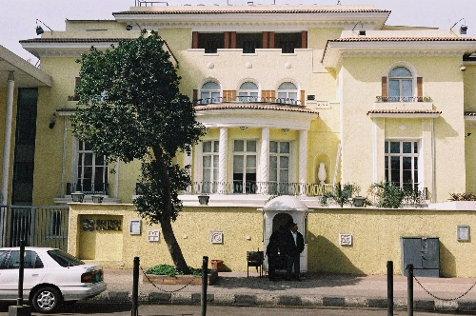

**The British Council, Agouza, Cairo**

The Agouza Teaching Centre is next to the River Nile. It has a garden and a private terrace for staff. There are 30 classrooms and a cafe. The Delta Module 2 course will take place in a dedicated training room which is booked from 08.30 – 21.00 seven days a week exclusively for Delta candidates. The training room has an interactive whiteboard and a library with the essential and recommended books for the course. You will also have access to the extensive resources in the Teachers’ Room. The training room has five computers and a printer which are available to access the internet and to prepare materials for lessons.

**What’s Cairo like?**

Cairo is the largest city in Africa and one of the largest in the world. It is situated on the River Nile in the north of Egypt. The population is constantly increasing as a result of immigration from the countryside and the high birth rate. The city is, consequently, expanding outwards as new suburbs, such as 6th October City, are built. Modern tower blocks exist side by side with a variety of other architectural styles, including picturesque villas and areas of narrow alleyways. To European eyes, initially, it is chaotic; the noise, heavy traffic, the overcrowding, dust and pollution can come as a shock, but this is compensated for by the sheer size, history and wonder of the city.

* **Transport upon arrival in Cairo**: When you arrive at the airport you will need to get a visa 250 LE (US$26). They only accept Dollars at the airport so make sure you have some. You can get a taxi at the airport to the centre of town and this will cost about 200 LE. Uber is now available in Egypt and their drivers are much more reliable.
* **Transport to the British Council:** This will depend where your hotel is located, but we will provide detailed instructions and a map to each candidate. A taxi from Zamalek to the British Council costs about 10 LE.

**Accommodation**

We don’t provide or arrange for accommodation. However, we have a list of reasonably priced hotels. The average cost of a hotel is about US$90 a night. We can also put you in touch with International Language Institute (IH Arabic school in Cairo) to rent a room in their students’ residence. The monthly rate is US$440.

**General living costs and conditions**

The cost of living depends a lot on how you live. Fresh food and vegetables are cheap but pre-packed European-style food is pricey. Imported goods are becoming more and more plentiful but also increasingly expensive. Eating out can be incredibly cheap (LE 10) for traditional Egyptian food in a ‘local’ restaurant or LE 30 – 50 in a more stylised Egyptian restaurant. Western food like pizza is reasonably priced (LE 70 – 100); a decent meal in a fashionable restaurant will set you back about LE 200 – 300 with a beer and including service. Fast food is everywhere in Cairo. There's a McDonalds on every corner, Pizza Hut, KFC and so on. If you’re a fast food fan you'll be in heaven; they all deliver to your home! There’s also a website, [otlob.com](http://otlob.com/), from which you can order home delivery from local restaurants too.

Local beers (lager) cost LE 25 from an off-licence but up to LE 50 for exactly the same thing in a bar. The local wine wouldn't win first prize in many competitions; it sells for LE 80-100 in smaller alcohol stores. Again, home delivery is available!

The current exchange rate is 1 GBP = 23 EGP (LE)

**Paying for the course**

After applicants have been accepted onto the course, they can either pay the £2000 Delta module 2 course fees to our bank in Cairo, via transfer, or directly at the British Council in Cairo by credit card or cash if paying in the equivalent in EGP. Unfortunately, there are usually bank fees to add on if you can’t pay in person.

**Payment by Bank Transfer**

Immediately upon acceptance to the Delta Module 2 course, you will need to transfer the course fee to our account in Cairo (details below). A note must accompany the transfer stating your name and that the funds remitted are for the 2018 Delta module 2 in Cairo. A photocopy of the transfer confirmation must be submitted to the British Council Cairo. British Council, Cairo is not responsible for any bank charges you may incur.

Details of the British Council bank are as follows:

Account Name:             British Council

**Account Number (EGP):      001-200112-001**

**Account number (GBP):  001-200112-110**

Bank Name:                  HSBC Bank Egypt

Branch Name:               Cairo Branch

Address:                       3 Abu El Feda Street- Zamalek –Cairo –Egypt.

SWIFT code:                 EBBKEGCX

**A typical day**

Each day involves two training sessions (1.5 hours each), individual tutorials with your Tutor and teaching practice. The centre is open from 8:00 am to 10:00pm seven days a week, so candidates have access to the resource and computer facilities for most of the time that they are not in input or teaching practice.

Please note, though, that this is a very intensive course and you will be expected to do reading and research for homework every evening as well as planning for your lessons. You should also expect to give up at least one day of your weekend to working on your assignments.

You may not have input and teaching practice every day but the exact schedule will not be determined until the start of the course.

**What to bring**

You must bring a laptop with you. This will enable you to work on assignments at times when you don’t have access to our computer facilities and, also, we do not have sufficient computers for each course participant to rely on them for lesson planning and writing your Diagnostic Assignment. Please note that it is not possible to use USB devices in our computers for BC anti-virus security reasons. We also currently don’t have Wifi connection. If you work on materials on your own computer, you will need to email them to yourself. This hasn’t caused serious problems in previous courses.

In terms of lesson materials, previous candidates have found it useful to have some of their favourite material with them that might be used in an initial lesson with an elementary, pre-intermediate or intermediate group. The Teachers’ Room has a wide range of course books and supplementary materials including CDs, DVDs, classroom equipment, photocopying facilities and lots of other materials and resources that teachers need. We also have a fully stocked Delta library.

**Climate**

In the summer, the weather can be quite warm during the day (between 30 and 40 degrees) though in the evenings the temperature can drop by 10 degrees meaning it is quite pleasant. The air conditioning in classrooms can be quite fierce, so you may want to bring a cardigan or jacket with you.

**Dress code**

The British Council Cairo dress code for teachers is that teachers are expected to wear smart-casual clothing, including skirts below the knee, upper-arms and shoulders covered for women and long trousers and closed shoes for men.

Staff should at all times dress neatly and present a professional appearance and should adhere

to the following guidelines:

* No revealing clothes (e.g. transparent or overly clingy garments, short skirts, sleeveless or low-cut tops, etc)
* No ‘beach-wear style’ clothes (e.g. plastic shoes / flip-flops, trainers, shorts, vests etc)  
  No jeans

**Travel and sight-seeing**

As most of your time during the course will be taken up with your studies, you may want to arrive early or stay on a few days to take the opportunity to go on excursions such as visits to the Pyramids, sailing down the Nile, or even horse riding.

**Contact Details**

For enquiries, please email: [cairo.celta@britishcouncil.org.eg](mailto:cairo.celta@britishcouncil.org.eg)

1. Some types of discrimination are based on characteristics about people they cannot control and so are classified as unlawful and unjustified. Generally, making a distinction between people for a range of reasons **not** related to their specific characteristics and protected by law is **not** unjustified discrimination.
2. Other irrelevant grounds could include, for example, language, accent, weight, although these on their own may not attract legal protection.