You can choose from three different texts - use one of them (not all, only one) to design a 60- 90 minute lesson for a group.

The lesson plan should contain information about the following:

* the target group/level/context
* the precise aims of the lesson
* a detailed language analysis of either the lexis or grammar you taught. This involves clear analysis of the meaning/use, form and pronunciation.
* a rationale for the lesson, that is, a justification of key planning choices made (up to 500 words).
* the procedure, probably in grid format, with information about the lesson stages, the purpose of each stage, a description of teacher and student activity, patterns of interaction and approximate timings.

The links to the three texts are here (you may need to click through advertising to access)

A [Twitter names in the Guardian](http://www.theguardian.com/world/2015/feb/17/rio-de-janeiro-twitter-account-given-away-for-free-by-spanish-shoeshiner)

B [Job listing article in the Atlantic](http://www.theatlantic.com/education/archive/2013/12/job-listing-40k-a-year-to-attend-harvard-university-as-me/282542/)

C [Expatriates in the Washington Post](http://www.washingtonpost.com/blogs/worldviews/wp/2013/11/05/want-to-move-abroad-this-map-shows-the-best-and-worst-countries-to-be-an-expatriate/)

or if you prefer there are copies of the texts at the end of this document

During your interview you will be asked to talk about some of the things you have focused on in the lesson you have planned and the reasons behind your choices.

You are not being asked to work out what level the texts suit, but can adjust the tasks to suit the level of the group you would like to use them with. The plan should be at least two pages long, but might be longer.

If you mention worksheets or exercises that you would use with your article, you should create them and include them.

Please also include your own evaluation of the lesson.

The lesson evaluation should contain information about the following:

* the effectiveness of the lesson you have described.
* the strengths and weaknesses in your planning and teaching.

The headings below may help you to organise your ideas.

|  |  |  |  |
| --- | --- | --- | --- |
| Stage aim | Procedure | Time | Interaction |
|  |  |  |  |
|  |  |  |  |

Group profile Lesson aims Procedure

Text A

# Rio de Janeiro Twitter account given away for free by Spanish shoeshiner

Javier Castano hands over the Twitter name @riodejaneiro for the Olympic Games and wants to give up

@Japan as well

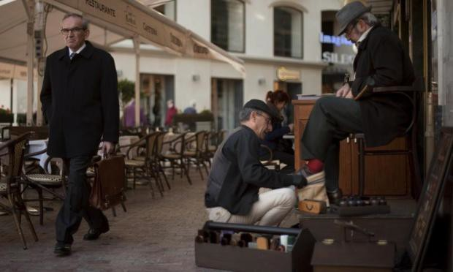Spanish shoeshiner Javier Castano shines shoes in Malaga. He has given the authorities in Brazil the Twitter name @riodejaneiro for publicising next year’s Olympic Games. Photograph: Jorge Guerrero/AFP/Getty Images

**Agence France-Presse**

Tuesday 17 February 2015 01.45 GMT Last modified on Tuesday 17 February 201502.17 GMT

Authorities in [Brazil](http://www.theguardian.com/world/brazil) have got hold of a valuable Twitter account to publicise next year’s Rio Olympics, after a humble Spanish shoeshine man surrendered the rights to it for free.

Javier Castano, 50, handed over the password for the Twitter name @riodejaneiro to Rio de Janeiro city hall – and said Monday he now wants to do the same with the handle @japan for the 2020 Tokyo Olympics.

Castano registered several key Twitter account names in 2007, when the online social network was in its early days.

He said he spent years sending messages to Rio city hall offering them the account. It said it has now finally replied to him and formally accepted.

Javier Castano poses in Malaga. Having given away the Twitter name @riodejaneiro to Rio de Janeiro city hall he now wants to do the same with the handle @japan.

Photograph: Jorge Guerrero/AFP/Getty Images

“We are very happy to at last be able to use the name of our city on the social network,” said Rio’s tourism secretary Antonio Pedro Figueira Mello in a statement.

“This will be of great value now that we are getting closer to the Olympics.”

Castano was formerly a graphic designer but saw work dry up in Spain’s recent economic crisis. He now earns about 30 euros ($34) a day shining shoes in the street in Malaga, southern [Spain.](http://www.theguardian.com/world/spain)

He insisted on giving the Twitter accounts only to the legitimate representatives of the Olympic host cities, for free.

“I am a shoeshine man with not much money, but I have the privilege of being able to give a gift to 130 million Japanese people or eight million people in Rio,” he said. “Could you do that?”

Castano has already handed over @canada and @madrid to authorities in those places, by sending them the passwords to the accounts once they formally accepted and confirmed their identity.

“I am very happy now. My only remaining task is to hand over @japan,” he said.

Japanese government officials however said they had never heard of Castano and voiced reservations about accepting Twitter accounts from private individuals.

“There is no discussion, as far as I know, about setting up new accounts,” said an official who helps publish tweets for the Japanese prime minister’s office.

Text B

# Job Listing: '$40K a Year to Attend Harvard University as Me'

'You do not need to worry about being accepted, I have already taken care of that.'

[ELEANOR BARKHORN](http://www.theatlantic.com/eleanor-barkhorn/)DEC 19 2013, 3:44 PM ET

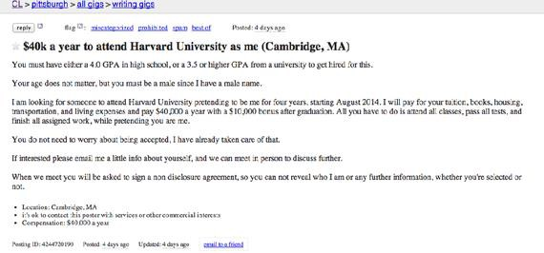

Craigslist

A male Craigslist poster in Pittsburgh [is looking](http://pittsburgh.craigslist.org/wrg/4244720190.html) for someone to attend Harvard University in his stead.

You must have either a 4.0 GPA in high school, or a 3.5 or higher GPA from a university to get

hired for this.

Your age does not matter, but you must be a male since I have a male name.

|  |  |
| --- | --- |
| I am looking for someone to attend Harvard University pretending to be me for four years, |  |
| starting August 2014. I will pay for your tuition, books, housing, transportation, and living |
| expenses and pay $40,000 a year with a $10,000 bonus after graduation. All you have to do is | |
| attend all classes, pass all tests, and finish all assigned work, while pretending you are me. |  |

You do not need to worry about being accepted, I have already taken care of that.

If interested please email me a little info about yourself, and we can meet in person to discuss

further.

*Politico*'s Libby Nelson's [response](https://twitter.com/libbyanelson/status/413767693364256768) seems about right: "This is the setup for a novel or something, right?" But if it *is* in earnest, we may never know: The last line of the posting warns potential applicants they'll have to sign a non-disclosure agreement, no matter whether they're selected or not.

Text C

# Want to move abroad? This map shows the best and worst countries to be an expatriate.

By Max Fisher November 5, 2013

China and Thailand are the two best countries to be an expatriate, according to a [recent study](http://www.expatexplorer.hsbc.com/%23/countries) by British bank HSBC that looked at economic opportunities and quality of life for expats in 34 countries. They're followed by small, rich countries known for their globalized business classes. In descending order, they are: Switzerland, the Cayman Islands, Bahrain and Singapore.

The worst of these 34 countries to be an expat is Egypt, which has seen xenophobia rise considerably since this summer's military coup and wave of populist nationalism. Also at the bottom of the list is much of Western Europe, which the report says is often too expensive for expats. In descending order: France, Spain, the United Kingdom, Italy and second-to-last is Ireland.

For 24 of those countries, the study also looked at metrics gauging the suitability of raising children as expats. If you incorporate the data on child rearing abroad along with the economic and quality-of-life measurements, China ranks first overall, following by Germany and Singapore. The study concludes that Germany is the best of these countries to raise expat children, that Thailand provides the best work-life experience for expats, and that Switzerland has the most favorable economy for expatriates.

This map shows how the 34 countries compare on economic opportunities and quality-of-life for expats. It does not include the metrics on child rearing. Bluer countries are better for expats and redder countries are worse:

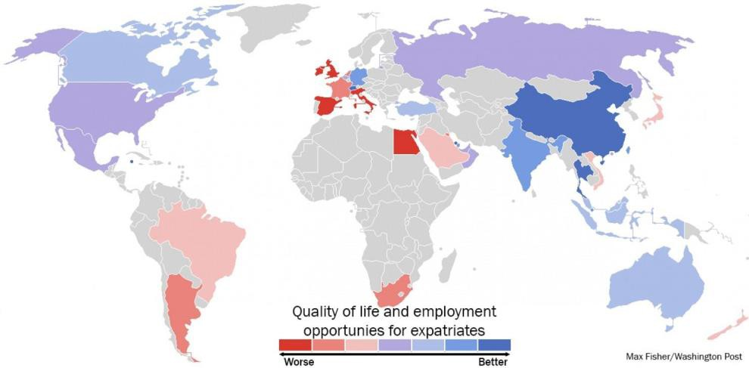

The best and worst countries to be an expat. Data source; HSBC. Click to enlarge. (Max Fisher/Washington Post)

You can see right away that the data are very favorable for expat life in Asia's developing economies. Companies in these countries prize expat workers and tend to [pay them 15 percent](http://www.expatexplorer.hsbc.com/finding/79/asia-still-leading-on-the-finance-front) [more](http://www.expatexplorer.hsbc.com/finding/79/asia-still-leading-on-the-finance-front), the report explains. This, combined with lower costs of living, can give expats much higher spending power than they'd enjoy elsewhere. Expats in East and Southeast Asia also tend to report that their social lives become [much more active](http://www.expatexplorer.hsbc.com/finding/84/social-butterflies-attracted-to-buzzing-streets-of-asia) on moving there, due perhaps to the boost in disposable incomes as well as better weather and proximity to beaches.

Still, I was surprised to see mainland China rank so high. The country's worsening air quality (here is the [most shocking photo of Chinese air pollution I've ever seen](http://www.washingtonpost.com/blogs/worldviews/wp/2013/02/28/the-most-shocking-photo-of-beijing-air-pollution-ive-ever-seen/)) and food safety issues ([watch this video on Chinese "gutter oil" if you dare](http://www.washingtonpost.com/blogs/worldviews/wp/2013/10/28/you-may-never-eat-street-food-in-china-again-after-watching-this-video/)), particularly severe in the major cities likely to host expats, have sent a number of expats packing as China once again becomes a "hardship" posting. Perhaps the economics really are that favorable to outweigh these costs.

Germany and Switzerland also scored well for expats, as both economies improve despite the larger European woes. Salaries for expats are [unusually high](http://www.expatexplorer.hsbc.com/finding/78/deutschland-delights-and-the-swiss-taste-of-success-against-wider-european-woes) in the German-speaking countries and expenses are lower than in the rest of the Europe, owing to export-driven economic growth. Strong social programs and high standards of living also tend to make the experience pleasant, even if expats do not live as a class-above as they do in many developing economies.

Middle Eastern countries tend be worse places for expats, owing to [legislation](http://www.expatexplorer.hsbc.com/finding/75/tough-property-rights-restrictions-in-the-middle-east) that makes it tougher for foreigners to own property and because of formal and informal social restrictions that can cut back on quality of life. The exceptions are Bahrain and Qatar, two very wealthy and very small Persian Gulf states whose governments work to attract the wealthy expats they see as crucial to building businesses there. It should go without saying that HSBC's study does not consider "guest workers" in its measurements. Gulf states, particularly Qatar, have notorious reputations for mistreating migrant laborers from South and Southeast Asia, who work in difficult conditions and with few protections.

A big surprise here may be the countries of Western Europe, which despite their wealth and high standards of living are considered among the worst countries to be an expat, according to the study. The report cites [high taxes](http://www.expatexplorer.hsbc.com/finding/96/high-taxes-and-expensive-public-transport-drive-up-the-cost-of-living-in-european-countries) and costly services; expenses that might make sense if you're a citizen who plans to one day employ your country's substantial social services, but less so if you're an expat who pays into those services but doesn't fully benefit. The European Union's ongoing financial problems also mean that salaries are [less competitive](http://www.expatexplorer.hsbc.com/finding/67/wealthy-earners-hubbed-in-europe), particularly compared to the higher cost of living. Part of this may be that Western European companies, as well as foreign companies with offices in Western Europe, are not as willing to invest in growth with all the economic uncertainty. Otherwise, though, Western Europe ranks highly for child rearing, with high-quality education and child services relatively affordable.

Based just on this report, if you're thinking about flying off for the life of an expat and you don't want to have kids there, then you should consider China, Thailand or someplace else in Asia.

And if you want to have kids abroad, then Germany should also be near the top of your list.