Once the tender has been published, it can be viewed at https://in-tendhost.co.uk/britishcouncil
Please follow below steps in order to view and apply for the tender

1- Create a log in on Intend Portal – Click on ‘Register’ tab. Please note that only yellow fields are mandatory for registration information on the portal.
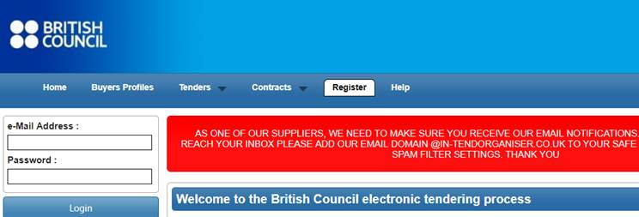

2- Click on Current under Tenders Tab ;
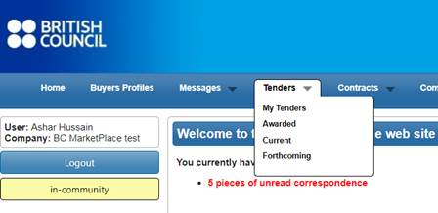
3- Click on the project title
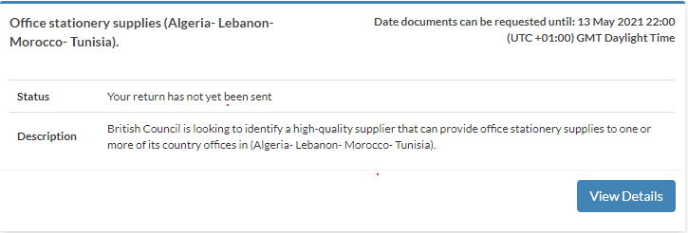

4- Click on Express Interest button at bottom

5- You will be able to view all the Project Details and documents under ITT
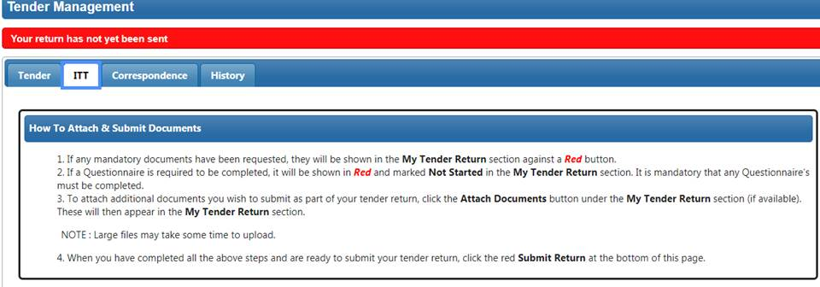

6- In order to submit your proposal, attach your proposal and Bid Value click on Submit Return button taking into consideration the deadline by May 13th 2021
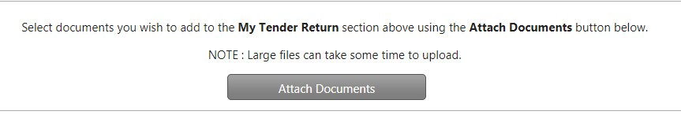

7- In case you want a clarification please send your correspondence to us by clicking on Correspondence Tab within the clarification defined timeline
